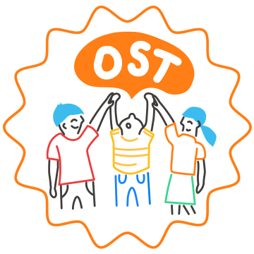
10 INDICATORS OF SITEWIDE SEL – STRENGTHS AND NEEDS REFLECTION
When fully implemented, sitewide SEL contributes to more successful and equitable outcomes for young people and is evidenced by the indicators below.
Directions: In the table below, reflect on the programs, practices, and strategies your site is already using to support each of the indicators of sitewide SEL. Then, reflect on how your community can grow the most. This reflection can be a helpful step in establishing common ground among stakeholders to determine where the school should focus their learning and implementation efforts for SEL.
 | Indicator of Sitewide SEL | Description | Assets that Already Support this Indicator | Areas for Growth
 | Explicit SEL Instruction & Programming | Youth have consistent opportunities to cultivate, practice, and reflect on social and emotional competencies in ways that are developmentally appropriate and culturally responsive.
 | Consistent Use of SEL Objectives | SEL objectives are integrated into instructional content and teaching strategies for instructional and non-instructional time as well as in OST programming and activities.
 | Youth Voice and Engagement | Adults honor and elevate a broad range of youth perspectives and experiences by engaging youth as leaders, problem solvers, and decision-makers.
 | Supportive Environments | All physical spaces promote a positive climate and are supportive, safe spaces focused on building relationships and community.
 | Focus on Adult SEL | Adults have regular opportunities to cultivate their own social, emotional, and cultural competence, ideally in contexts that bring together staff from different teams.
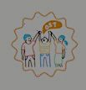 | School and OST Collaboration & Alignment | Staff from the school and OST program collaborate with one another, work to build trusting relationships across teams and roles, and maintain a strong community for the youth they serve.
 | Indicator of Sitewide SEL | Description | Assets that Already Support this Indicator | Areas for Growth
 | Supportive Discipline | Discipline policies and practices are instructive, restorative, developmentally appropriate, aligned between school and OST partners, and equitably enforced.
 | A Continuum of Integrated Supports | SEL is seamlessly integrated into a continuum of academic and behavioral supports, which are available to ensure that all youth needs are met.
 | Authentic Family Partnerships | Families and staff have regular and meaningful opportunities to build relationships and collaborate to support youth social, emotional, and academic development.
 | Aligned Community Partnerships | Staff and community partners align on common language, strategies, and communication around all SEL-related efforts and initiatives.
 | Systems for Continuous Improvement | Implementation and outcome data are collected and used to continuously improve all SEL-related systems, practices, and policies with a focus on equity.

